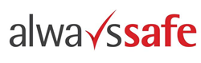

Alert Title
Date

BACKGROUND

CIRCUMSTANCES

What was working?

Immediate Actions taken

RECOMMENDATIONS

What have we learnt?

What can we do?

Details of the actions to prevent recurrence

Authorised By:

